Olympic challenge 2
Top 10 results:
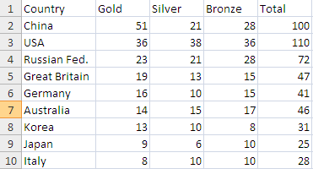
Things to consider:
Population of country
Size of country

China
The population of china is 1,331,460,000
The HDI score of china is 0.772
Number of competitors: 407

USA
The population of the united states of America is 307,006,550
The HDI score of china is 0.902
Number of competitors: 536

Russian federation
The population of the Russian federation is 141,856,000
The HDI score of russia is 0.719
Number of competitors: 456

Great Britain
The population of theBritain is 59,093,800
The HDI score of Britain is 0.766
Competitors:259

Australia
Population:21,874,000
HDI: 0.937
Competitors:482

Korea
Population:48,747,000
HDI: 0.877
Competitors:300

Japan
Population:127,560,000
HDI: 0.884
Competitors:283

Italy
Population:60,221,211
HDI: 0.854
Competitors:400

Conclusion
Comparing the amount of competitors, the wealth of the country and the population the country with the most athletic population is Australia. The reason for this is the population and number of competitors is unusually small for the amount medals that the country has gained.

